Functional Decomposition Map
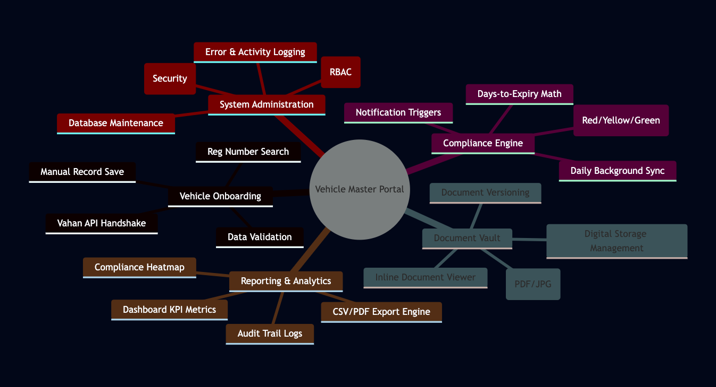

1. Vehicle Onboarding Module
- Reg Number Search: Primary entry point for entering Indian vehicle plate numbers.
- Vahan API Handshake: The logic that communicates with the external (mock) government database.
- Data Validation: Ensuring the fetched data (dates, make, model) is in the correct format.
- Manual Record Save: Capability to create a fleet record even if the API returns no data.

2. Compliance Monitoring Engine
- Days-to-Expiry Math: The backend logic calculating $(ExpiryDate - CurrentDate)$.
- Status Mapping: Translating days into visual states (Compliant, Warning, Expired).
- Notification Triggers: Identifying which vehicles need an alert sent today.
- Daily Background Sync: A scheduled task to update statuses without user intervention.

3. Digital Document Vault
- Secure File Upload: Interface to browse and upload RC/Insurance copies.
- Digital Storage: The folder structure and naming convention for stored files.
- Inline Viewer: The ability to see the document preview within the Streamlit UI.
- Versioning: Handling the replacement of old documents with renewed ones.

4. Reporting & Analytics
- Dashboard KPIs: Visual cards showing "Total Fleet" vs "Total Fines Risk."
- Export Engine: The function that converts database rows into a downloadable CSV.
- Compliance Heatmap: A visual summary of the fleet's health at a glance.

5. System Administration & Security
- Access Control: Ensuring only authorized roles can delete or edit records.
- Input Sanitization: Stripping malicious characters to prevent SQL Injection.
- Logging: A "Black Box" that records system errors for troubleshooting.

